**EXPERIMENT 2**

**AIM:** To obtain the output and transfer characteristics of MOSFET Using PSPICE

simulation software.

**SOFTWARE REQUIRED:** PSPICE Software.

**DEVICES USED:** MOSFET IRF150

**THEORY:**

**OUTPUT CHARACTERISTICS:**

The output characteristics is a graph of drain current iDversus drain to source voltage VDS for different values of gate to source voltage VGS as shown in Figure.

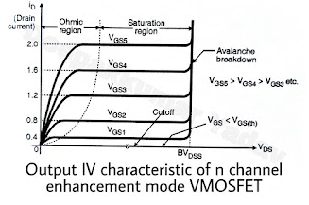

* The saturation, cut-off and ohmic regions of the characteristics are also shown in Figure In the power electronic applications where the MOSFET is used as switch, the device must be operated in the cut-off and ohmic region when turned off and on respectively.
* The operation in the saturation region should be avoided to reduce the power dissipation in the on state. (The on state voltage across the MOSFET is high in the saturation region).

**WHEN The MOSFET is in the cut-off state when the gate source voltage VGS is less than the threshold voltage VGS(th).**

The device must withstand to the applied voltage and to avoid the breakdown the drain to source breakdown voltage should be greater than the applied voltage. The breakdown takes place due to the avalanche breakdown of the drain body junction.

**When a larger positive gate to source voltage is applied the power MOSFET goes into the ohmic region where the drain to source voltage VDS(on) (on) is small.**

* In this region of operation the power dissipation can be kept reasonably low, by minimising the on state voltage.
* In the saturation region the drain current i(D) is almost independent of the drain to source voltage VDS. It is only dependent on the gate to source voltage VGS.

In the saturation region the gate voltage VGS is greater than the threshold voltage VGS(th) and the drain current increases with increase in VGS.

**TRANSFER CHARACTERSTICS**

The transfer characteristics relates the drain current I(D) response to the input gate-source driving voltage V(GS) . Since the gate terminal is electrically isolated from the remaining terminal (drain, source, and bulk), the gate current is essentially zero, so that gate current is not part of device characteristics . The transfer characteristics curve can locate the gate voltage at whicgh the transistor passes current and leaves the OFF-state. This is the device threshold voltage V(tn). Figure shows the input characteristics for an nMos with a small potential across their drain to source terminals.

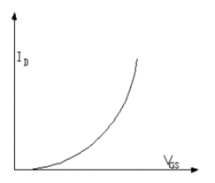

**SCHEMATIC**

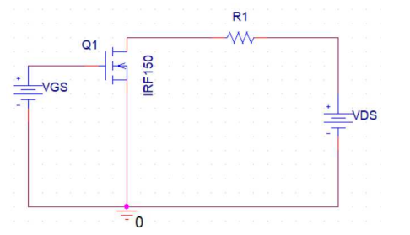

**PROCEDURE**

Make the connections as shown in the schematic

**Output characteristics:**

From the datasheet, find the range of threshold voltage (Vgs)

* Fix the Vgs to its minimum value
* Vary the value of VDS from 0 to 25V with a step size of 0.1V and obtain the value of Id
* Obtain the curve with Id on y-axis and VDS on x-axis
* Repeat the steps 1 to 5 for different values of VGS with an increment of 0.5V until its
* maximum value (which is mentioned in the datasheet).